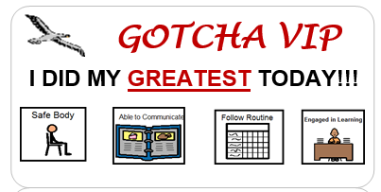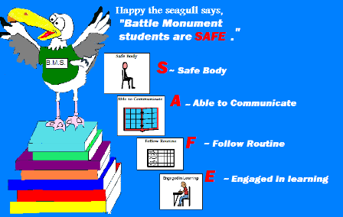

**List of School-Wide Programs and Tiered Interventions:**

**Gotcha Awards Purpose:** Recognizing and rewarding behaviors aligned with the school code of conduct. *SAFE* behaviors are immediately recognized when a student displays self-initiated and/or outstanding examples of *SAFE* behavior. **How**: A *SAFE* sticker is given to the student and may be placed on their shirt or a piece of paper. The specific behavior, (S.A.F.E.) is circled so that as the student travels around the building wearing the sticker or it is displayed on a wall, other staff can complement the student on their achievement.

**Classroom Gotcha Award Chart** **Purpose**: To provide incentives and individual rewards to students receiving 1 or more Gotchas during the month. **How:** Each Classroom will display the Gotcha awards for each student during the month. Classrooms will award student group based awards and/or individual rewards depending on the students and the classroom needs. Students can redeem Gotcha awards for BMS dollars to spend at the school store on a bi-weekly basis*. ** Please email your Gotcha VIP totals at the end of the month to Kim or fill them in on the chart on the shared drive.*

**Safe Student of the Month Purpose**: To recognize students that display exemplar *SAFE* behaviors and continue to be a role model for our learning community. **How:** Safe students are nominated at the end of the month by their teacher. Criterion for the nomination is based on the number of Gotchas the student earned and/or a significant achievement involving the *SAFE* code of conduct. The teacher submits the name and a brief paragraph to Kim Fell at the end of the month. The award is presented to the student at the Monthly Celebration Ceremony.

**Safe Staff of the Month Purpose:** To recognize staff who display *SAFE* behaviors and continue to be a role model for our learning community. **How:** Throughout the month, staff recognize fellow staff members for *SAFE* behavior by putting a post-it on a bulletin board stating the name of the staff and what they did that showed *SAFE* behavior. At the end of the month, a post-it is randomly selected from the board. That staff member gets a certificate at the Monthly Celebration Ceremony and picks a prize from a prize box.

**Code of Conduct:**

**PBIS Program at**

**Battle Monument School**

Tier 1

* Highly structured environment (consistent schedule/routines, high level of engagement, structured student breaks, very little if any unstructured down-time, visual supports which can include first/then charts, picture symbols, etc.)
* High staff to student ratio
* Visual schedule
* Sensory support
* Toileting support and training
* Social skills training w/social worker – zones of regulation, circles, skill streaming
* Intense transition planning w/social worker
* Mindfulness training/relaxation techniques
* Frequent reinforcement surveys
* Check-in/check out

**Monday is SAFE shirt day! Students and staff wear BMS spirit wear!**

Tier 3

* FBA
* Behavior Intervention Plan

Tier 2

* Individual schedules
* Token chart/first then charts
* Social stories
* Specialized groups such as “Girl’s Group”